Lab - Installing Print Services on Windows Server 2012 R2

Overview

In this lab, students will learn to install and configure Print Services in their Server 2012 R2 network environment. Print Services allows the networking of print devices for all sizes of network from the small office to a global enterprise. Some offices needing just one printer such as a small network, we may not want to install print services, but is you manage a large number of networked print devices, you will need to install printer services to be able to manage the printers centrally.

Hardware Required

* Server 2012 R2 running in a domain environment
* Windows 7 Client joined to the domain

Install and Configure Print Server

Log in to your 2012 R2 server as an administrator. Wait for the Server Manager console to fully load. Your Server 2012 domain must have the following roles present.

* Active Directory
* DHCP Server
* DNS Server

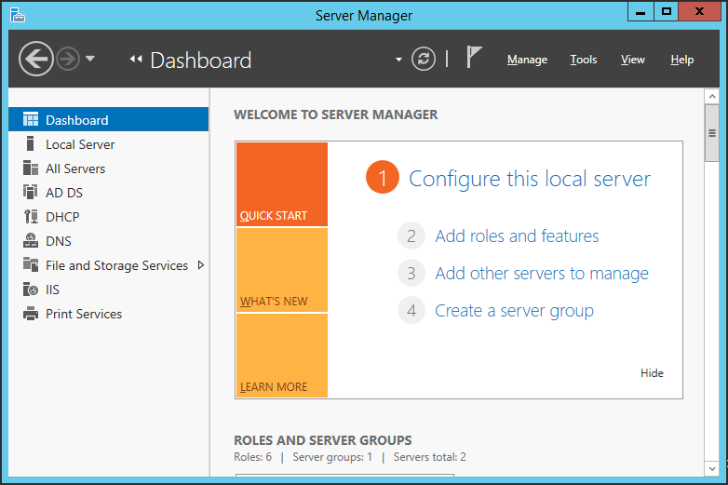

On the Before You Begin page click Next and select Role-based, or feature base installation then clicks Next.

[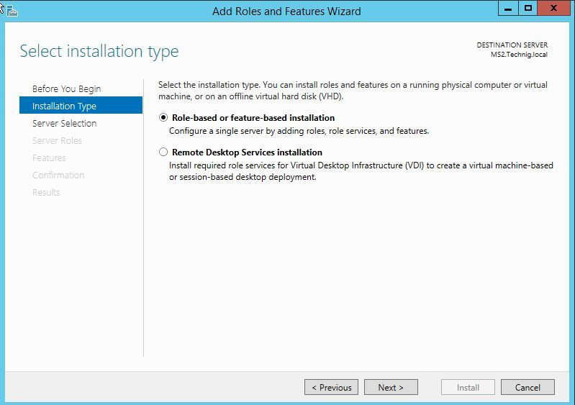](https://i1.wp.com/www.technig.com/wp-content/uploads/2015/02/Role-based-or-Feature-based-installation-page.jpg)

On the Server Selection page, choose the server you want then click Next.

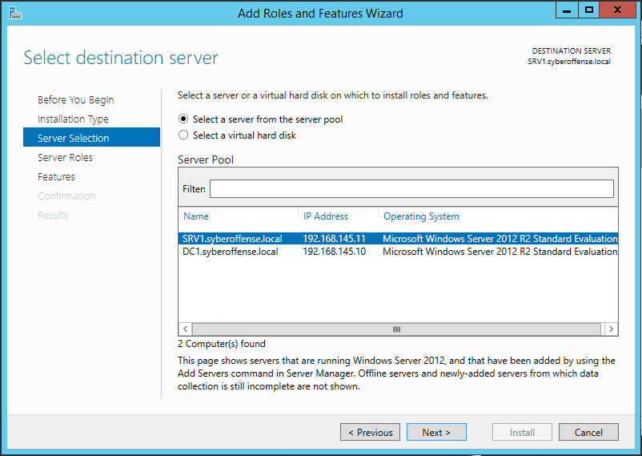

Select and tick the checkbox of Print and Document Services on the Server Roles page.

[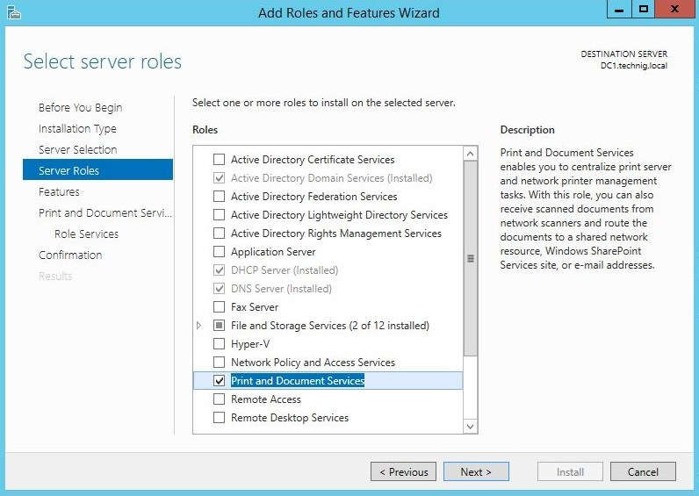](https://i0.wp.com/www.technig.com/wp-content/uploads/2015/07/Print-and-Document-Services.jpg)

On the Print and Document Services page click Next.

[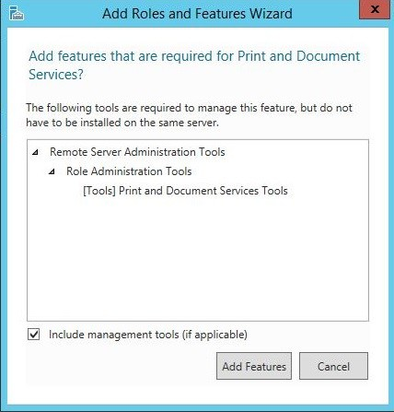](https://i0.wp.com/www.technig.com/wp-content/uploads/2015/07/Install-and-Configure-Print-Server.jpg)

Select the Print Server and Internet Printing options from Role Services.

[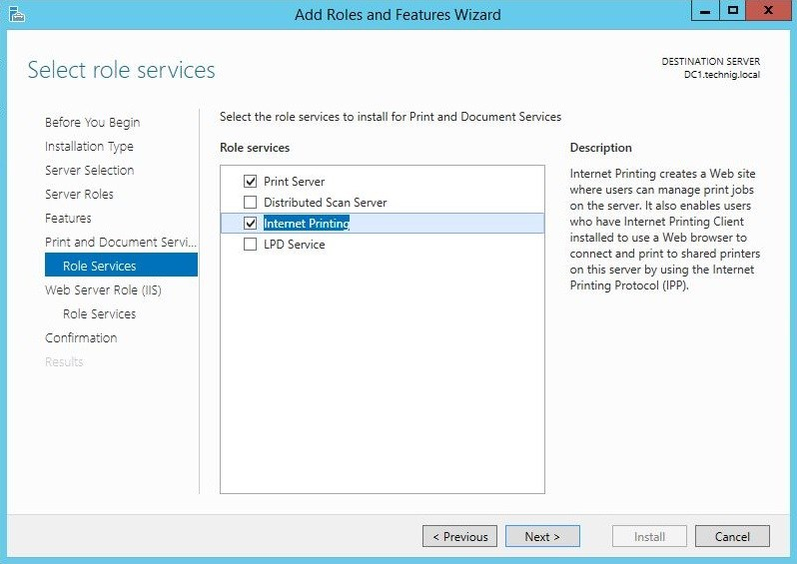](https://i1.wp.com/www.technig.com/wp-content/uploads/2015/07/Internet-Printing.jpg)

Select the Print Server and Internet Printing options from Role Services.

[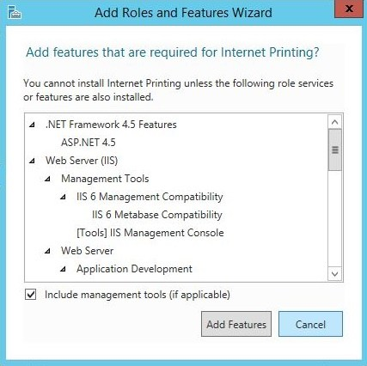](https://i2.wp.com/www.technig.com/wp-content/uploads/2015/07/Internet-Printing-Features.jpg)

Click Add Feature to install IIS web server with components and features.

Print and Document Role Services:

* Print Server is the core print management and services.
* Distributed Scan Server is for Document Scanner if you have it.
* Internet Printing will let you manage your printers through the browser.
* LDP Services will share printers between Linux and Unix based OS.

Print Server Installation Process

[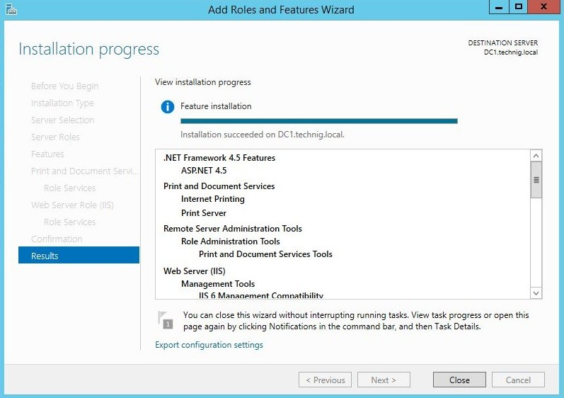](https://i2.wp.com/www.technig.com/wp-content/uploads/2015/07/Print-Server-Installation-Process.jpg)

Finally click Close to finish the installation process. The Print and document services complete successfully.

Install Printers

Open the print management console from tools tab in Server Manager.

[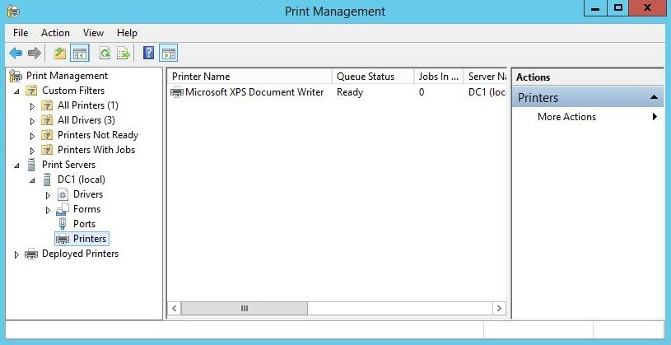](https://i1.wp.com/www.technig.com/wp-content/uploads/2015/07/Print-Management.jpg)

In the left window pane, expand Printer Servers, expand your printer server, right click on Printers and from the context menu select, Add Printer.

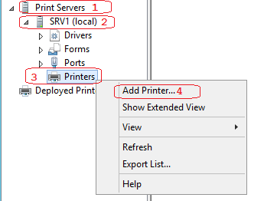

On Printer installation page select Add a new printer using an existing port and click Next.

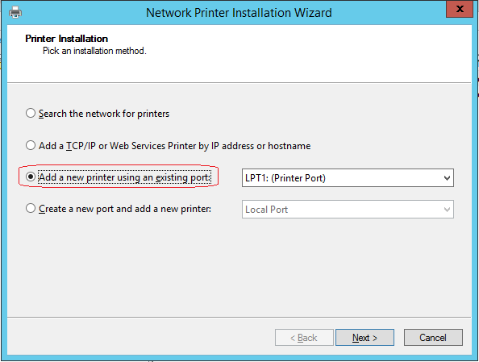

Select Install a new driver on Printer Driver page and click Next.

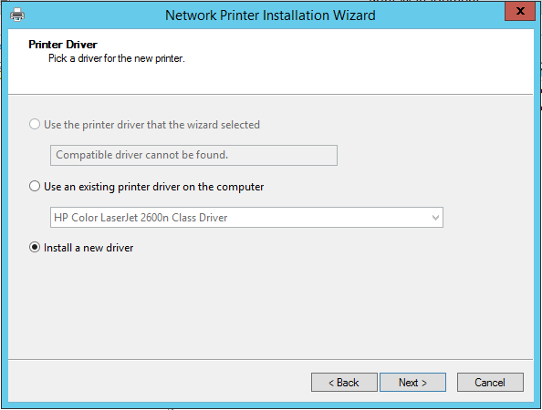

Select a proper printer then click Next. I have selected a LaserJet 2500n HP printer.

[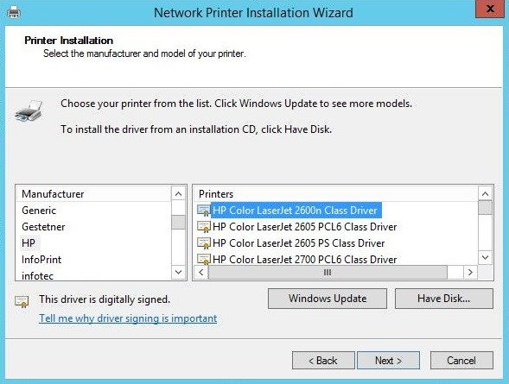](https://i2.wp.com/www.technig.com/wp-content/uploads/2015/07/Printer-Models.jpg)

Fill the information and tick the checkbox of Share this printer and click Next twice.

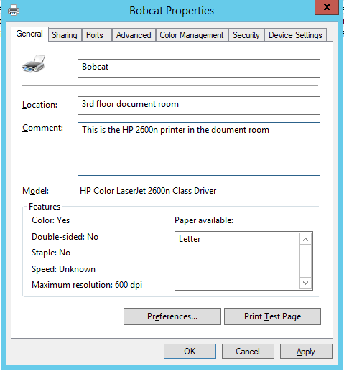

Fill the information and tick the checkbox of Share this printer and click Next twice.

[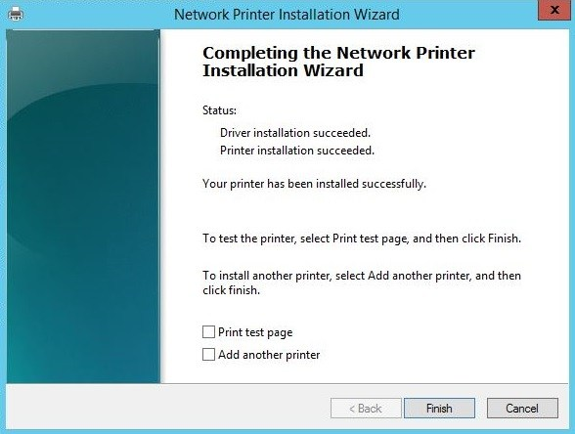](https://i2.wp.com/www.technig.com/wp-content/uploads/2015/07/Network-Printer-Installation.jpg)

Finally, click finish to accomplish the installation task.

Go to the print management console and see the new printers. I have installed another printer, and now I have two printers.

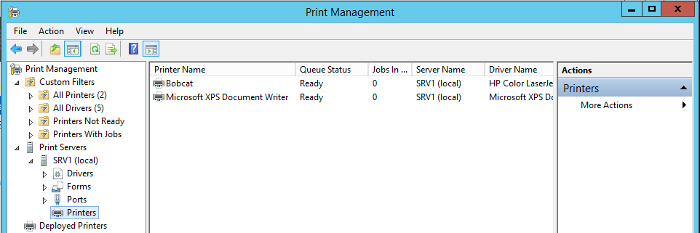

Sharing Printers for Clients

There are two types of printer shares, the share itself and the share we create when we publish the printer share in Active Directory. Publishing a printer in Active Directory makes the printer easier to be found by users

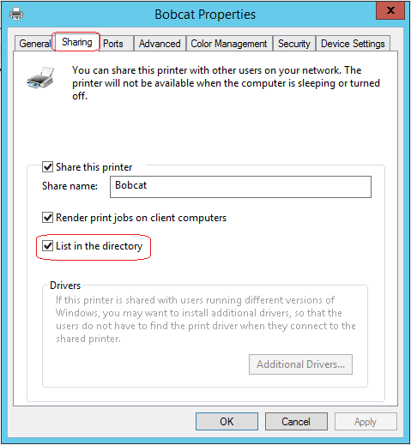

End of the lab!